1. Write a Java program to print 'Hello' on screen and your name on a separate line.

class Rk{

public static void main(String args[]){

System.out.println("Hello");

System.out.println("Ram Lovewanshi");

}

}

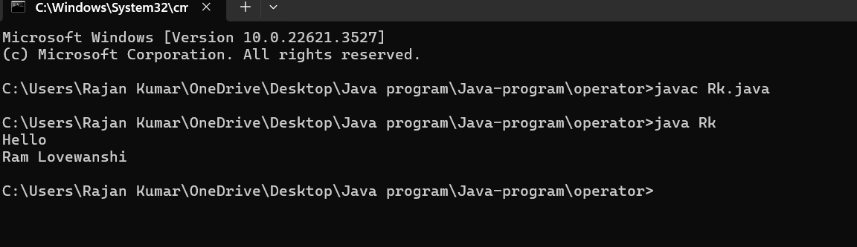

1. Write a Java program to print the sum of two numbers.

import java.util.Scanner;

class Sumab{

public static void main(String args[]){

int a,b,c;

Scanner tk=new Scanner(System.in);

System.out.println("Enter the first number:");

a=tk.nextInt();

System.out.println("Enter the second number:");

b=tk.nextInt();

c=a+b;

System.out.println("Sum of two number:"+c);

}

}

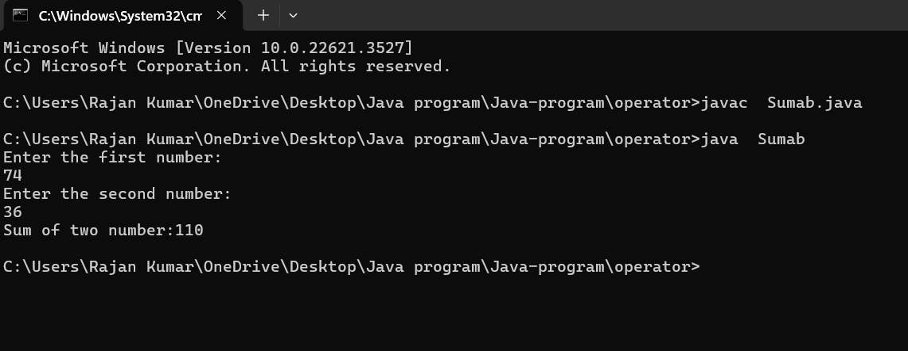

1. Write a Java program to divide two numbers and print them on the screen.

import java.util.Scanner;

class rks{

public static void main(String args[]){

int a,b,c;

Scanner sc=new Scanner(System.in);

System.out.println("Enter the first number:");

a=sc.nextInt();

System.out.println("Enter the second number:");

b=sc.nextInt();

c=a/b;

System.out.println("Division of two number:"+c);

}

}

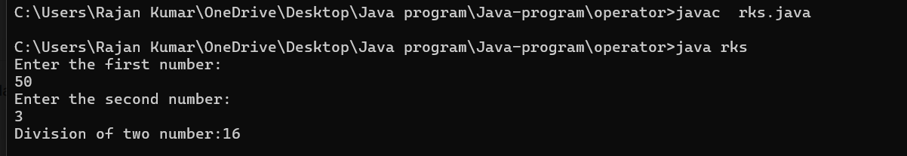

1. class unun{
2. public static void main(String args[]){
3. int a,b,c,d;
4. a=-5 + 8 \* 6;
5. b=(55+9) % 9;
6. c=20 + -3\*5 / 8;
7. d=5 + 15 / 3 \* 2 - 8 % 3;
8. System.out.println("a:"+a);
9. System.out.println("b:"+b);
10. System.out.println("b:"+c);
11. System.out.println("d:"+d);
12. }
13. }

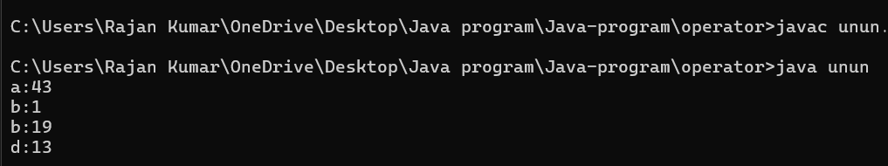

5.

import java.util.Scanner;

class mul{

public static void main(String args[]){

int a,b,c;

Scanner sc=new Scanner(System.in);

System.out.println("Enter the first number:");

a=sc.nextInt();

System.out.println("Enter the Second number:");

b=sc.nextInt();

c=a\*b;

System.out.println("Multiplication:"+c);

}

}



6.

import java.util.Scanner;

class Allopr{

public static void main(String args[]){

int a,b;

Scanner rk=new Scanner(System.in);

System.out.println("Enter the first number:");

a=rk.nextInt();

System.out.println("Enter the second number:");

b=rk.nextInt();

int c=a+b;

int d=a-b;

int e=a\*b;

int f=a/b;

int g=a%b;

System.out.println(c);

System.out.println(d);

System.out.println(e);

System.out.println(f);

System.out.println(g);

}

}

